**Transfusion PROCEDURE Alert – Previous Antibody Identified & Previous Transfusion Reaction**

**March 25, 2015**

**Problem/Issues:**

* Physicians place an order to transfuse, but it is the nurse who performs this procedure.
* Lab receives S.A.F.E. reports regarding delays in Cross Match and STAT availability of product which typically are due to previous transfusion procedures in the patient’s history.
* Transfusion procedure complications at San Mateo Medical Center are rare, but patients who have been previous transfused (or pregnant) have an increased risk of adverse reaction....(i.e., developing RBC antibody, receiving donor antibodies from plasma, severe acute reactions leading to hemolysis of patient’s red blood cells)
* Patient’s with positive antibody screens, or positive DAT’s, previous transfusion reactions, require donor blood that is compatible to avoid further transfusion associated events (ie., RBC hemolysis, TRALI, Acute Respiratory Distress, etc.). Ensuring the donor unit is compatible with the recipient requires additional processing time in blood bank.
* Emergent uncrossmatched unit or a least incompatible unit may be issued at any time with a phone call to Blood Bank and provider approval. Should the provider not wish to use uncrossmatched or least incompatible, the additional testing for both the patient and the donor blood may take an additional 1-3 hours (in most situations).

**Description:**

**Transfusion Reaction Investigation Rule**

The purpose of the rule is to alert the physician when placing ordering labs for products that the patient is at risk for a Blood Transfusion Reaction. The Transfusion Reaction Investigation Rule will listen for various Blood Product Lab Orders. Once heard, the rule will check to see if there has been a transfusion reaction result and display the result if one exists (most recent result).

**Antibody ID Rule**

The purpose of the rule is to alert the physician when ordering a Type & Screen Lab that the patient is noted to have previous history of antibodies. The Antibody Rule will listen for a type and screen lab order. Once heard, the rule will check to see if there has been an antibody ID result with any value. If a result exists (most recent) then the rule will display “Previous RBC antibodies.

**Details:**

Once you selected the blood product you wish to order, the screen below will display. The link on **Transfusion Reaction Investigation Rule** and **Antibody ID rule** will take you to the most recent result.

**View of the Antibody ID result**



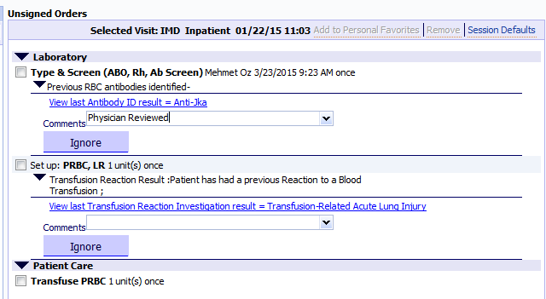

**View of the Transfusion Reaction Investigation result**



Tips #4 2015

CA 03/23/2015