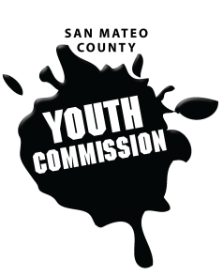
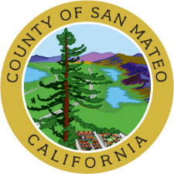
San Mateo County Youth Commission

225 37th Avenue – Room 100
San Mateo, CA 94403

September 27, 2018
6:00-8:15 PM

Public Meeting

6:00 p.m. Welcome & Swearing In – Supervisor Carole Groom

6:15 p.m. Call to Order

- Approve Agenda (Action)

- Public Comment
Members of the public may address the commission on youth related issues and concerns that are not currently on the agenda. Please complete a Request Form found in the front entry, hand it to one of the Youth Commission Chairs, and limit your remarks to two minutes. The public is welcome to speak on Agenda Items throughout the meeting.

- Youth Commissioners Introductions

- Youth Adult Partnerships & Hart’s Ladder Presentation – Eduardo Gonzalez

- Boards & Commissions Introductions
Brief introductions from county board and commission representatives followed by opportunities for youth commissioners to network and engage with representatives

- Review Executive Board Roles & Responsibilities
Brief review of positions on the Executive Board, agenda setting, and commitments

- Review Committee & Secretary Voting Processes

- Elect Committee Chairs, Vice Chairs, Secretaries
Positions selected from within committees, approved by commission vote

- Approve Committee Chair Nominations (Action)

- Elect Commission Secretary (Action)

- Indigenous Peoples’ Day Resolution (Action)
Discussion of 2017-2018 Immigrant Youth Committee’s resolution to add Indigenous Peoples’ Day to the San Mateo County calendar

- Executive Board – Meeting Schedule
Executive Board meetings will be the 1st Thursday of each month

- Commission Liaison Updates

- County Updates

- Staff Updates

- Announcements

- Adjournment

Next Executive Board Meeting: October 4, 2018
Next Workgroup Meeting: October 18, 2018
Next Public Meeting: October 25, 2018

Public records that relate to any item on the open session agenda for a regular or special meeting of the Youth Commission are available for public inspection. Those records that are distributed less than 72 hours prior to the meeting are available for public inspection at the same time they are distributed to all members, or a majority of the members of the Commission. Those public records are available to be sent electronically by emailing awilson@yli.org or calling (650) 513-0893.

IN COMPLIANCE WITH THE CALIFORNIA GOVERNMENT CODE AND THE AMERICANS WITH DISABILITIES ACT: The meetings of the Youth Commission are accessible to individuals with disabilities. Contact Adam Wilson at (650) 513-0893 or at awilson@yli.org as soon as possible prior to the meeting, if (1) you need special assistance or a disability-related modification or accommodation, including auxiliary aids or services, in order to participate in this meeting; or (2) you have a disability and wish to receive the meeting notice, agenda packet or other writings that may be distributed at the meeting in an alternative format. Notification in advance of the meeting will enable the Youth Commission to make reasonable arrangements to ensure full accessibility to this meeting and the materials related to it.

