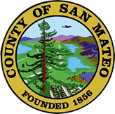
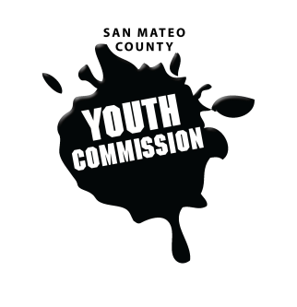
San Mateo County Youth Commission

Room 100

225 37th Ave.
San Mateo, CA 94403

September 21, 2017

6:00-8:15 PM

Workgroup Meeting

- Call to Order

- Approve Agenda

- Public Comment
Members of the public may address the commission on youth related issues and concerns that are not currently on the agenda. Please complete a Request Form found in the front entry, hand it to one of the Youth Commission Chairs, and limit your remarks to two minutes. The public is welcome to speak on Agenda Items throughout the meeting.
- Introductions & Icebreaker

- Review Group Agreements

- Adopt Group Agreements (Action)

- Boards & Commissions Mixer
Brief presentations from county board and commission representatives followed by opportunities for youth commissioners to engage with representatives

- BREAK

- Review Executive Board Roles & Responsibilities
Clara MacAvoy & Sophia Vahanvaty
Brief review of positions on the Executive Board, agenda setting, and commitments
- Review Committee & Secretary Voting Processes
Adam Wilson
- Elect Committee Chairs, Vice Chairs, Secretaries (Action)
Positions selected from within committees, approved by commission vote

- Elect Commission Secretary (Action)

- Executive Board – Meeting Schedule

- Commission Updates

- County Updates
- Staff Updates
- Announcements

- Adjournment 1 min

Next Workgroup Meeting: October 20, 2016
Next Public Meeting: September 22, 2016

Public records that relate to any item on the open session agenda for a regular or special meeting of the Youth Commission are available for public inspection. Those records that are distributed less than 72 hours prior to the meeting are available for public inspection at the same time they are distributed to all members, or a majority of the members of the Commission. Those public records are available for public inspection at the Human Resources office located at 455 County Center, 5th floor, Redwood City, CA 94063 by appointment. The documents are also available to be sent electronically by emailing awilson@yli.org or calling (650) 513-0893.

IN COMPLIANCE WITH THE CALIFORNIA GOVERNMENT CODE AND THE AMERICANS WITH DISABILITIES ACT: The meetings of the Youth Commission are accessible to individuals with disabilities. Contact Adam Wilson at (650) 513-0893 or at awilson@yli.org as soon as possible prior to the meeting, if (1) you need special assistance or a disability-related modification or accommodation, including auxiliary aids or services, in order to participate in this meeting; or (2) you have a disability and wish to receive the meeting notice, agenda packet or other writings that may be distributed at the meeting in an alternative format. Notification in advance of the meeting will enable the Youth Commission to make reasonable arrangements to ensure full accessibility to this meeting and the materials related to it.

