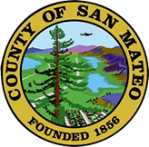
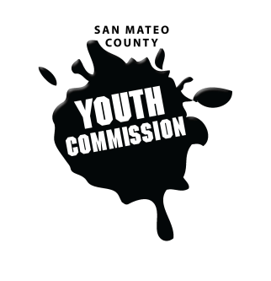
San Mateo County Youth Commission

1500 Purissima Creek Rd, Half Moon Bay, CA 94019

August 25, 2018

10:00 AM – 4:30 PM

Group Agreements

- Be Respectful
- One Mic - Pay attention to speaker
- Step up, step back – allow others the chance to speak
- Be respectful with cellphone use
- Share responsibility and workload
- Come to meetings and be on time
- Cooperate, compromise, collaborate
- Communicate
- Be committed - come up with a plan and stick to it
- Be engaged & participate

Retreat Meeting

- Public Comment
Members of the public may address the commission on youth related issues and concerns that are not currently on the agenda. Please complete a Request Form found in the front entry, hand it to one of the Youth Commission Chairs, and limit your remarks to two minutes. The public is welcome to speak on Agenda Items throughout the meeting.

- Welcome

- Introductions

Name, pronouns, grade, school, fact

- Group Agreements

- Overview of San Mateo County Structure & Youth Commission

Structure, partnerships, leadership, history, procedural rules, terminology

- Snack and Energizer

- Equity, Diversity, and Cultural Humility – Shireen Malekafzali

- Data Driven Policy Work – Justin Watkins

- Lunch

- Committee Brainstorming
Review committee topics, overview of project processes

- Snacks and Team Building

- Affirmation Activity

- Announcements

- Closing

- Adjournment
Next Workgroup Meeting: September 20, 2018
Next Public Meeting: September 27, 2018

