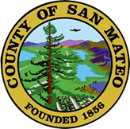
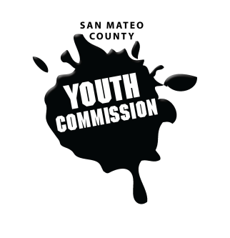
San Mateo County Youth Commission

1670 S Amphlett Blvd, Suite 250
San Mateo, CA 94402

Join online at:
https://zoom.us/j/649187163

May 3, 2018

5:30-7:30 PM

Executive Board Meeting

- Call to order

- Roll call

- Public comment
Members of the public may address the commission on youth related issues and concerns that are not currently on the agenda. Please complete a Request Form found in the front entry, hand it to one of the Youth Commission Chairs, and limit your remarks to two minutes. The public is welcome to speak on Agenda Items throughout the meeting.

- Approve agenda

- Approve minutes

- Check-in

- May meeting planning

- 2018-2019 recruitment updates and planning

- Dates for presentation to Board of Supervisors

- Committee reporting structure

- Voting structure review for chair & vice chair

- Updates
Chairs, Staff, Commission liaisons

- Announcements

- Adjournment

Next Workgroup Meeting: May 17, 2018
Next Public Meeting: May 24, 2018

