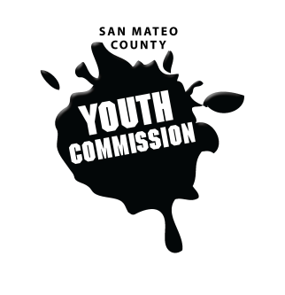
San Mateo County Youth Commission

1670 S Amphlett Blvd, Suite 205
San Mateo, CA 94402

Join online at:

https://zoom.us/j/781350265

December 7, 2017

5:30-7:30 PM

Executive Board Meeting

- Call to order

- Roll call

- Public comment
Members of the public may address the commission on youth related issues and concerns that are not currently on the agenda. Please complete a Request Form found in the front entry, hand it to one of the Youth Commission Chairs, and limit your remarks to two minutes. The public is welcome to speak on Agenda Items throughout the meeting.

- Approve agenda

- Check-in/Icebreaker

- Committee descriptions for website due

- Support process for other groups

- Agenda for end of year meeting

- January meeting planning – winter retreat options

- Committee updates on committee projects/focuses

- Discuss work plans for committees

- Updates
Committees, Chairs, Staff, Commissions

- Announcements

- Adjournment

Next Workgroup Meeting: January 18, 2018
Next Public Meeting: January 25, 2018

Public records that relate to any item on the open session agenda for a regular or special meeting of the Youth Commission are available for public inspection. Those records that are distributed less than 72 hours prior to the meeting are available for public inspection at the same time they are distributed to all members, or a majority of the members of the Commission. Those public records are available to be sent electronically by emailing awilson@yli.org or calling (650) 513-0893.

IN COMPLIANCE WITH THE CALIFORNIA GOVERNMENT CODE AND THE AMERICANS WITH DISABILITIES ACT: The meetings of the Youth Commission are accessible to individuals with disabilities. Contact Adam Wilson at (650) 513-0893 or at awilson@yli.org as soon as possible prior to the meeting, if (1) you need special assistance or a disability-related modification or accommodation, including auxiliary aids or services, in order to participate in this meeting; or (2) you have a disability and wish to receive the meeting notice, agenda packet or other writings that may be distributed at the meeting in an alternative format. Notification in advance of the meeting will enable the Youth Commission to make reasonable arrangements to ensure full accessibility to this meeting and the materials related to it.

