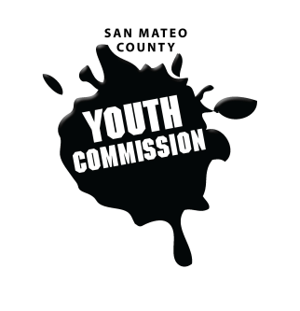
San Mateo County Youth Commission

Board of Supervisors Chambers
400 County Center
Redwood City, CA 94063

November 17, 2016

6:15-8:15 PM

Group Agreements

- Be Respectful
- One Mic - Pay attention to speaker
- Step up, step back – allow others the chance to speak
- Be respectful with cellphone use
- Share responsibility and workload
- Come to meetings and be on time
- Cooperate, compromise, collaborate
- Communicate
- Be committed - come up with a plan and stick to it
- Be engaged & participate

Public Meeting

- Call to Order 1 min

- Roll Call 1 min

- Public Comment 10 min
Members of the public may address the commission on youth related issues and concerns that are not currently on the agenda. Please complete a Request Form found in the front entry, hand it to one of the Youth Commission Chairs, and limit your remarks to two minutes. The public is welcome to speak on Agenda Items throughout the meeting.

- Approve Agenda 1 min

- Approve Minutes 1 min

- Check-in/Icebreaker 10 min
Clara MacAvoy & Dom Hauscarriague

- Being an Ally 25 min
Jeneé Litrell, Administrator, Safe and Supportive Schools/Student Services, SMCOE

- Systems of Oppression 25 min
Adam Wilson

- BREAK

- Discussion on Youth Conference 10 min
Theme and design ideas

- Vote on Youth Conference Theme 5 min

- Meetings for December 2 min

- Committee Time 20 min

- Updates 5 min
Committees, Chairs, Staff, Commissions

- Announcements 5 min

- Adjournment 1 min

Next Meeting: December 8, 2016

