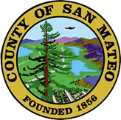
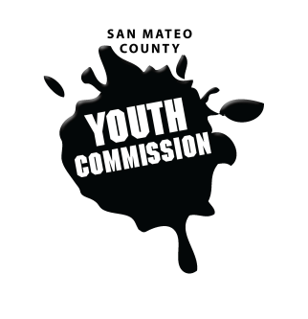
San Mateo County Youth Commission

Diamond Room

225 37th Ave.
San Mateo, CA 94403

January 12, 2017

6:15-8:15 PM

Executive Board Meeting

- Call to Order 1 min

- Roll Call 1 min

- Public Comment 10 min
Members of the public may address the commission on youth related issues and concerns that are not currently on the agenda. Please complete a Request Form found in the front entry, hand it to one of the Youth Commission Chairs, and limit your remarks to two minutes. The public is welcome to speak on Agenda Items throughout the meeting.

- Approve Agenda 1 min

- Approve Minutes 1 min

- Check-in/Icebreaker 5 min

- Plan for remaining meetings 30 min

- Updates 30 min
Committees, Chairs, Staff, Commissions
Potential for collaboration between committees
Youth Conference updates
Recruitment

- Announcements 5 min

- Adjournment 1 min

