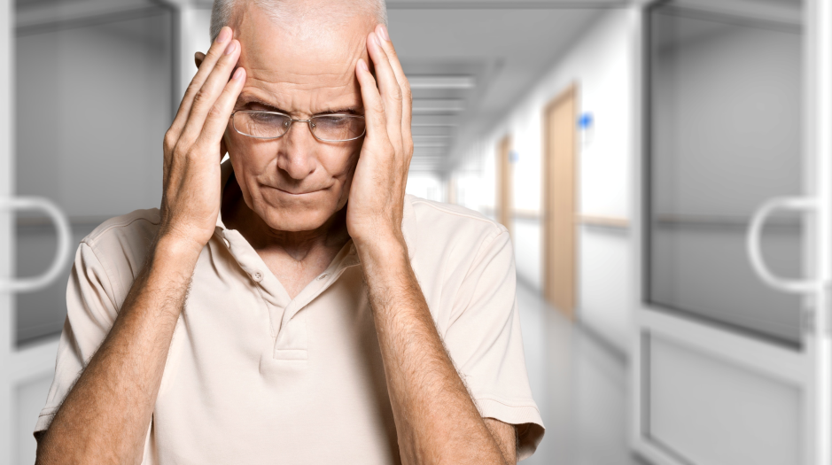

**Stroke Case Study: From Dispatch to Discharge 12:30**

***Moderator:* Gregory H. Gilbert, MD, FAAEM**

*San Mateo County EMS Medical Director*

**Panel**

**David Brenner, EMT***, American Medical Response*

**Nicholas Cassel, EMT***, American Medical Response*

**Kemp Hare, EMT-P***, American Medical Response*

**Scott Parsley, EMT-P***, American Medical Response*

**Jenny Im, RN**, *Stroke Coordinator, Mills-Peninsula Health Services*

**Jason Bryant, MD**, *Emergency Department, Mills-Peninsula Health Services*

**Tom Door**, *Stroke Survivor*

**Break 1:30**

**Implementation of Telemedicine Services: 1:45**

**Trials, Tribulations and Success**

***Moderator:* Gregory H. Gilbert, MD, FAAEM***,*

*San Mateo County EMS Medical Director*

**Panel**

**Prasha Govindarajan, MD**

*Associate Professor of Emergency Medicine, Stanford Health Care*

**David Tong, MD**, *Medical Director, Telemedicine Network,*

*California Pacific Medical Center*

**George Oldham, MD**, *Medical Director, Emergency Department*

*Dignity Health Sequoia Hospital*

**Jeffrey Klingman, MD**, *Assistant Chief of Staff and Chief of Neurology*

*Kaiser Permanente Redwood City Medical Center*

**Jenny Im, RN**, *Stroke Coordinator, Mills-Peninsula Health Services*

**Jake Jung, PharmD***, In-Patient Pharmacy Supervisor,*

*Kaiser Permanente Redwood City Medical Center*

**Wrap Up, Final Questions, Evaluations 3:30**

**Gregory H. Gilbert, MD, FAAEM,**

*San Mateo County EMS Medical Director*

**Linda Allington, RN, MPH**

*San Mateo County EMS Clinical Services Manager*

**Program**

**Welcome – EMS Stroke System Update 8:15**

**Linda Allington, RN, MPH**

*San Mateo County EMS Clinical Services Manager*

**Gregory H. Gilbert, MD, FAAEM**

*San Mateo County EMS Medical Director*

**Robert Telfer Memorial Lecture 8:25**

**Neuro Anatomy and Physiology**

**Joey English, MD**

*Stroke Medical Director, Mills-Peninsula Health Services*

**What’s New in the Prehospital Setting? 9:20**

**Mobile CT**

**Joey English, MD**

*Stroke Medical Director, Mills-Peninsula Health Services*

**iTREAT and mNIHSS for Fire and First Responders**

**Prasha Govindarajan, MD**

*Associate Professor of Emergency Medicine, Stanford Health Care*

**Break 10:20**

**DEFUSE 3: NIH Trial 10:35**

**Gregory Albers, MD**

*Stroke Medical Director, Stanford Health Care*

**Gregory H. Gilbert, MD, FAAEM,**

*San Mateo County EMS Medical Director*

**Coiling Versus Clipping Intracranial Aneurysms 11:25**

**Prasad Reddy, MD**

*Department of Neurosurgery*

*Kaiser Permanente Redwood City Medical Center*

**Break 12:15**

**CONTINUING EDUCATION INSTRUCTIONS**

**RN**

***This course is approved for 7.0 Contact Hours by the California Board of Registered Nursing Provider No. CEP5037***

***You must SIGN-IN and COMPLETE EVALUTION FORM in order to receive your course completion certificate.***

**EMT/Paramedics**

***This course is approved for 7.0 Hours of Instructor-based EMS CE by San Mateo County EMS Provider No. 41-001.***

***You must SIGN-IN , COMPLETE POST TEST and COMPLETE EVALUTION FORM in order to receive your course completion certificate.***

**COURSE COMPLETION CERTIFICATES WILL BE DISTRIBUTED AT THE CONCLUSION OF THE PROGRAM FOR FULL ATTENDANCE**

**Learning Objectives**

* **Discuss the evaluation of stroke through the use of telemedicine**
* **Describe prehospital assessment and treatment of stroke**
* **Understand care of the stroke patient across the continuum**

**SAN MATEO COUNTY**

**2016 STROKE SYMPOSIUM**

**A MATTER OF TIME**