New Lab Priority list (Add-on Order) in Soarian – Specimen in LAB
Problems/Issues:
- Currently, there is no Add-on orders for specimen already available in the Lab.
Description/Procedures:
- The new priority option “Specimen in LAB” is a Lab procedure enhancement in adding a Lab order indicating that there is a current specimen collected in Lab. The “Specimen in Lab” order will be sent directly to lab with an automated comment that these are add-on orders.
- All orders with Specimen in LAB priority will pass to NOVIUS lab with the priority of AD and order comment of “Specimen in LAB”. Label(s) will auto-print to the Red label printer.
- The Specimen in LAB priority can be used for any type of lab order.
- When Soarian orders are given the 'Specimen in LAB' priority, the Specimen Requisition for Lab box will be automatically checked to make that order (including 'Nurse Collect') cross NOVIUS Lab.
Details:
- The procedure will start by inquiring Lab Department if there is still a specimen available in the lab. After determining that the specimen is still available, go to tab and select the Lab order you wish to order. Below the Order Source is the Priority list, scroll down and select Specimen in LAB as shown below.
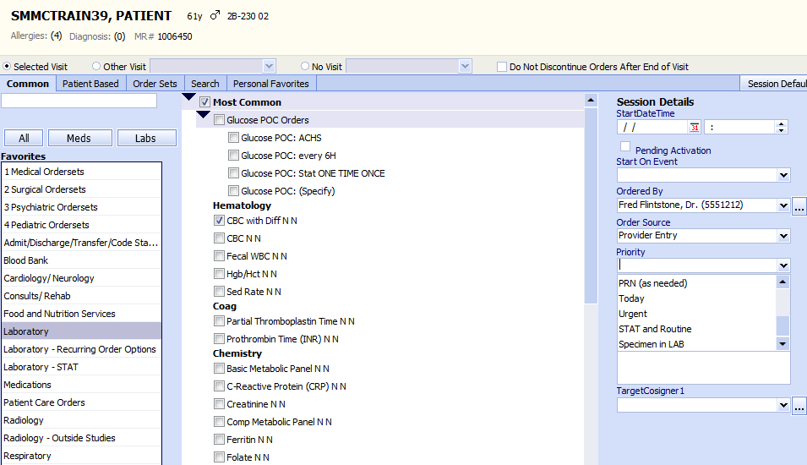
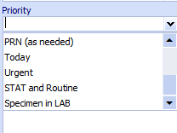
- For Blood Specimen, the order will go directly to the Unsigned Orders with a written entry “Specimen in LAB”. Click sign and label(s) will be auto-printed in LAB with a comment Specimen in LAB.
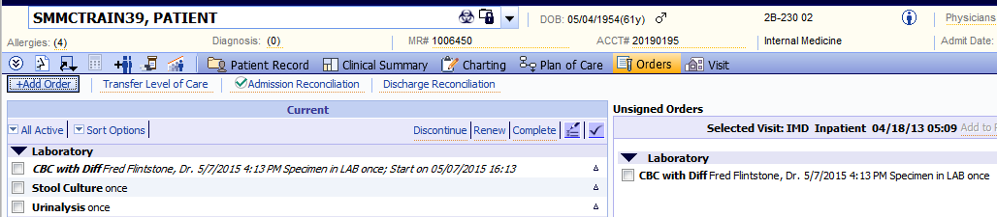
- For Body Fluids such as urine, stool, CSF fluid, peritoneal fluid, pleural fluid, and synovial fluid, etc, the order screen will open for further details. The Specimen in LAB will default to the Priority list if you selected it up-front. Otherwise, you may need to select the Specimen in LAB on this screen.
This box will be automatically checked so ALL add-on order will cross to NOVIUS Lab. Click “Order and Finish”

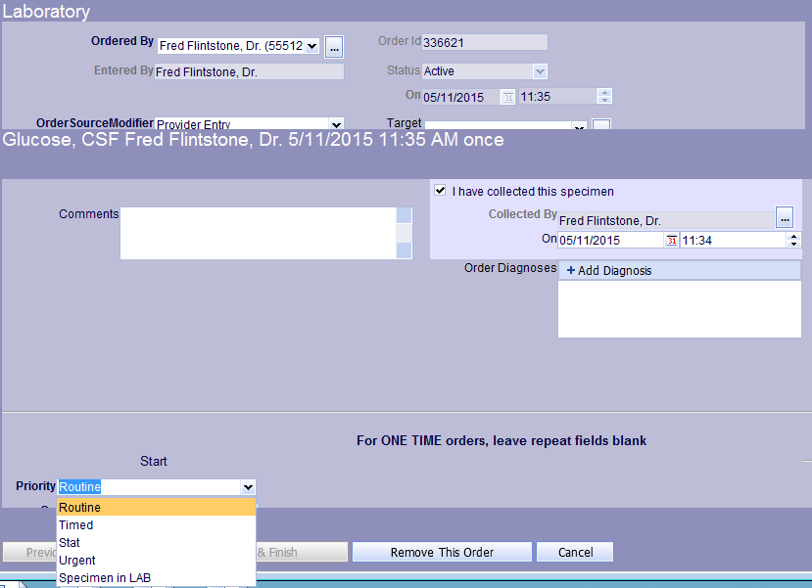
Ca05/12/2015

