Physician Fee Schedule Search Cheat sheet
Website
https://www.cms.gov/apps/physician-fee-schedule/license-agreement.aspx
First Step – License for Use – Click Accept
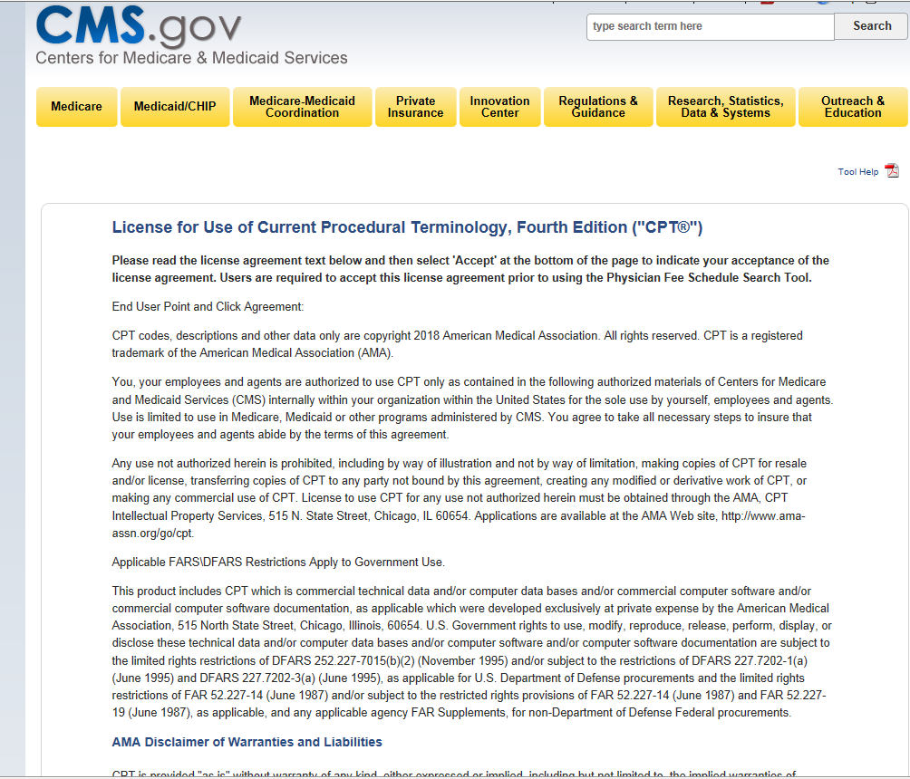

How to check HCPC Code (CPT code)
- Select the year
- Select Type of Information = Pricing Information
- Select HCPCS Criteria = Single, List or Range – typical Single HCPCS Code
- Select MAC Option = Specific Locality
- Select HCPCS Code = e.g. 90791
- Modifier = All Modifier
- MAC Locality = e.g. San Mateo County or whichever county for claims submission
- Then Click SUBMIT
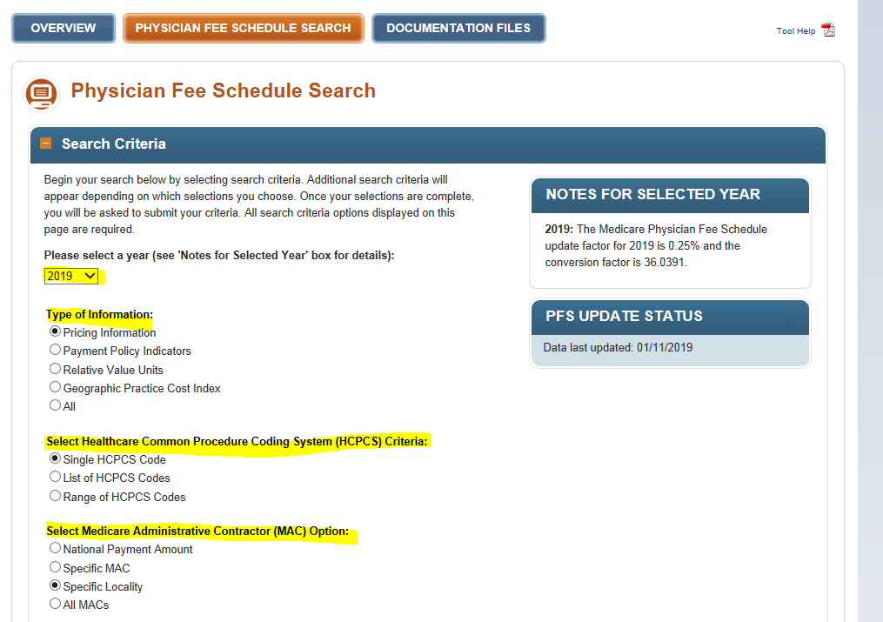
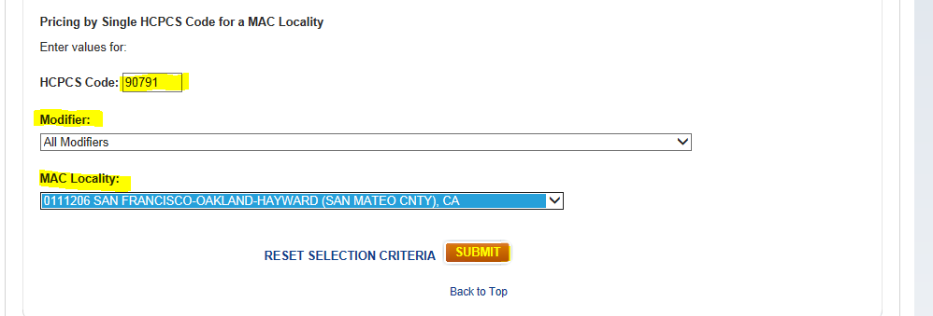
Search Results
- For Outpatient Claims = Use NON FACILITY PRICE
- For Inpatient Profees, SNIFF or Residential = Use FACILITY PRICE
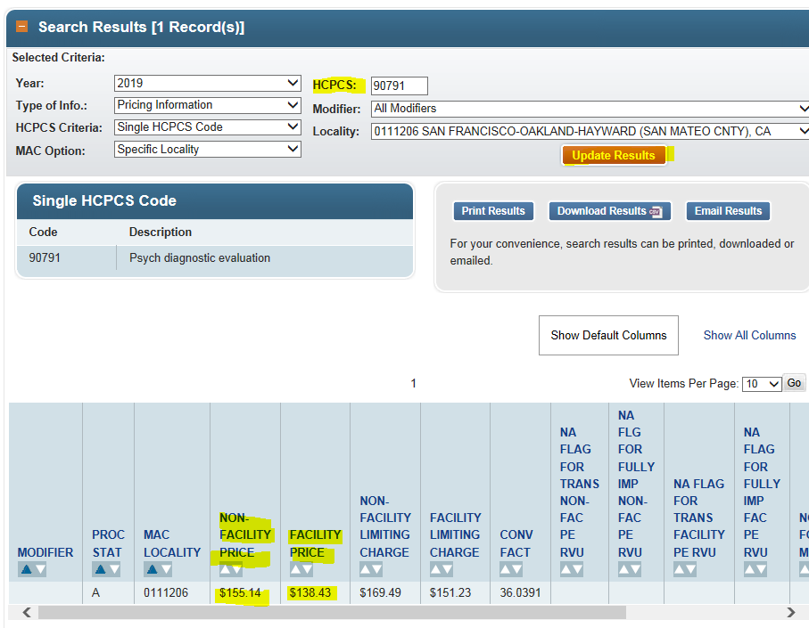

NOTE: You can search another HCPCS code from the display above and change the HPCS code and click Update Results.

