Biofeedback
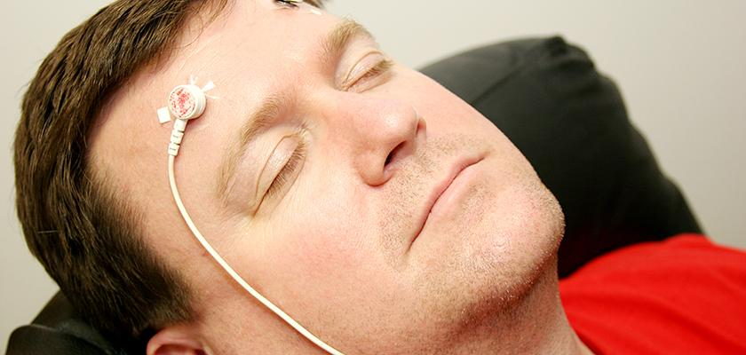

What is biofeedback?
- Biofeedback is a treatment that helps you understand and improve stress in your body
- Special equipment is used to measure things like your breathing, heart rate, the temperature of your skin and muscle tension
- Your doctor will use a computer to help you see how stress impacts your body and how you can learn to improve your breathing to reduce stress
- You will use that information to learn how to balance your body and improve your health

What are the main problems that biofeedback treats?
- Migraine & tension headaches, other types of pain
- Stress and anxiety
- Stress-related high blood pressure, high blood sugar, insomnia
- PTSD and depression (combined with psychotherapy)

What should I expect?
- Usually biofeedback lasts 5-10 sessions that are in-person (San Mateo Medical Center or Fair Oaks Health Center) and last 45-50 minutes each
- To benefit, you need to show up for every appointment and be willing to dedicate at least 15 minutes every day to practice techniques learned in sessions
- Biofeedback is an active treatment where your effort will be the biggest factor in your own healing! “If something can be measured, it can be managed!”

How do I get referred?
- Ask your doctor if biofeedback may be appropriate and to be referred to the Integrated Behavioral Health program
- Someone will contact you to schedule an appointment to make sure biofeedback is a good fit for your goals

To learn more: https://www.smchealth.org/general-information/integrated-behavioral-health

